# LTspice Transmission Line Lab

# Seth Ricks

# ECEN 390

Brother Swenson

**ECEN–390: LTspice Transmission Line Lab (60 points)**

(jas, LTspice Transmission Line Lab.docx, 10/03/2025)

**Note: This is a CAD lab to be done individually, rather than in teams, although please help each other out if/when opportunities arise, avoiding plagiarism. Submit an electronic version of a lab report to receive credit for doing this lab.** The goal of your **lab report is to provide sufficient documentation so that others could re-create your results.** Therefore, simply add to this document to arrive at your lab report, as all of the explanatory text, procedures and Discussion and Conclusion questions contained in this document are required for a complete lab report. So, for your lab report, **add a cover page, your results, along with your answers to the Discussion and Conclusions questions to the existing lab document**. Your answers to the **Discussion and Conclusions** questions are to **be uniquely yours** and not a copy of someone else’s answers to these questions. Your cover page is to include class, lab title, and author. A grading rubric for this lab is included at the end of this document. The rubric does not need to be included in your lab report.

**Purpose:** To better understand Transmission Lines and impedance matching.

**Procedure:**

**Part 1 – Power Flow on a Transmission Line.**

Providing maximum power from the source to load is a common goal for certain applications and is accomplished by impedance matching. For circuits that are electrically short, transmission line effects can be ignored, and maximum power transfer occurs when the generator impedance equals the load impedance, i.e., which simplifies to for purely resistive circuits. For circuits that are electrically long, transmission line effects can impede the power transfer and must be included. For the circuit of **Figure 1** below with sinusoidal excitation and a lossless transmission line, the average power delivered to the load, is given as follows:

For the circuit of **Figure 1** below with characteristic impedance Z0 = 100 Ω, calculate the average power delivered to the resistive load RL. Since Rg = Z0 = Rload in this application, the average power delivered to the load is also the largest average power, i.e., maximum power transfer, that can be provided by the generator circuit of **Figure 1**. Using 3 significant figures, include your calculated Pload_av value below along with units. (Note: An LTpsice simulation is not needed for Pload_av, rather use simple hand calculations.) (2 points.)

**Figure 1.** Generator and Load Circuit for an Electrically Long Circuit.

Pload_av =

Given that wavelength λ = up/f, where up is the propagation velocity and f is the frequency, the propagation velocity up = fλ. The propagation delay time for a signal to travel along the length of a transmission line can be determined as follows: Td = L/up = L/fλ. For a ½ wavelength long transmission line, Td = λ/(2fλ) = 1/(2f), while Td = 1/(4f) for a ¼ wavelength long transmission line. When simulating transmission lines, the propagation delay time Td can be used to define the length of the line without needing to know the actual propagation velocity up for a given cable. The LTspice lossless transmission line **tline** component uses the propagation delay time to define the length of the transmission line, and allows users to set the propagation delay, i.e., **Td**, and characteristic impedance, i.e., **Z0**.

Note: There is something buggy about the LTspice **tline** component at the load end of the line, that can result in a load voltage Vload equal to zero, when it should not be zero. Consequently, placing the load resistor Rload after placing the **tline** component is recommended during circuit construction. If your circuit has load voltage Vload equal to zero with the desired sinusoidal signal applied, try deleting then replacing load resistor Rload.

**Part 2 – ½ Wavelength Transmission Line.**

Transmission lines that are ½ wavelength long have the property that the input impedance Zin equal ZL, for any characteristic impedance Z0. Hence, when a ½ wavelength long transmission line is used, matching Zg and ZL results in maximum power transfer, regardless of the characteristic impedance Z0. This maximum power transfer approach can be used when the generator and load impedances are not equal to standard available transmission line characteristic impedance values.

1. Calculate the propagation delay time Td required for a ½ wavelength long transmission line for a 50 MHz sinusoidal traveling wave and use your calculated value as **Td** for the **tline** component placed in the following step. The propagation delay time for a signal to travel along the length of a transmission line can be determined as follows: Td = L/up = L/fλ.

1. Construct the circuit shown below in **Figure 2** in LTspice with the voltage source **Vg** configured to provide a 1 V peak (2 V pk-pk), **50 MHz sine wave** with 0 V DC offset. The sine wave voltage source symbol shown in **Figure 2** can be found in the [Misc], library as a **signal** component, although the standard voltage source also works in the simulation. The lossless transmission line can be found in the main library as a **tline** component. Modify the propagation delay, i.e., **Td**, to equal your calculated value for a ½ wavelength line. Set the characteristic impedance parameter, i.e., **Z0**, equal to 50 Ω, noting that . Configure the simulation to do a transient analysis of duration 200 ns. Add the Net Names **Va** and **Vload** as shown in **Figure 2** by means of the net name icon  to readily plot those voltages in the plot pane. In the **Edit** pull-down menu, add your name to your schematic as follows: **Edit 🡪 Aa Text**.
2. When completed with your schematic, replace the schematic shown in **Figure 2** below with your version, including your name. (7 points.)

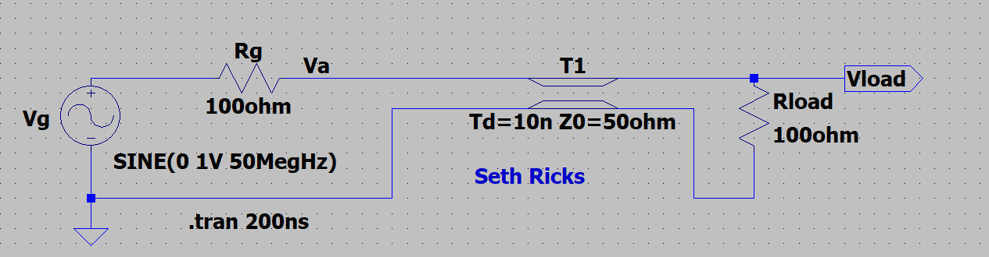

**Figure 2:** Simulation Circuit for a ½ Wavelength Transmission Line Circuit.

1. After running the simulation, a Plot Pane will open in which you are to select the waveforms **V(va)** and **V(vload)** for display. Also go to **Plot Settings 🡪 Mark Data Points** to see each individual simulated data point.
2. Next zoom in on the plot by going to **Plot Settings 🡪 Manual Limits**, which opens a **Plot Limits** pane in which to adjust the horizontal axis limits to span from 100 ns to 200 ns with a 20 ns tick.

Note: LTspice uses a dark background for the default plot pane, which makes it hard to visibly see some trace colors such as dark blue. The **Tools** 🡪 **Control Panel** 🡪 **Waveforms** 🡪 **Color Scheme** 🡪 **Background** allows you to modify the background color with Red = Green = Blue = 255 resulting in a white background. This is an optional change that you may find improves waveform viewing. If you make this change, it is also recommended to navigate to **Tools** 🡪 **Control Panel** 🡪 **Waveforms** and change the **Data Trace** and **Cursor width** from 2 to 3, along with using a Bold Font for the waveform labels so that the traces, cursors are waveform labels are more easily visualized.

1. Using one of the waveform cursors, determine the peak voltage of both **V(va)** and **V(vload)**. Both the mouse and the left and right arrow keys can be used to move the waveform cursors along a given trace. The cursors move to the next data point with the arrow keys, whereas the mouse provides for cursor location between actual data points.
2. Next drag the cursor pane onto your plot to document your peak values as illustrated in the figure below.
3. In the Plot Settings pull-down menu on the main LTspice toolbar, annotate your plot with your name as follows: **Plot Settings 🡪 Notes & Annotations 🡪 Place Text**.
4. Replace the plot pane in **Figure 3** below with your version. Note: The vertical axis has been altered in the plot shown below, meaning your results should look differently on the vertical axis. (8 points.)

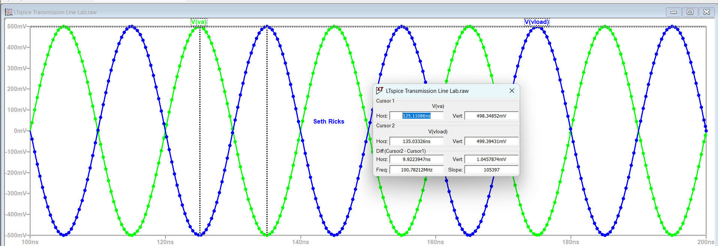

**Figure 3:** Simulated Results for a ½ Wavelength Lossless Transmission Line Circuit of **Figure 2**.

1. Record your simulated peak values of **V(va)** and **V(vload)** below in **Table 1**, along with a calculated **Pload_av** value, including units for all values. For the circuit of **Figure 2**, since ≠ 0, for , and **V(vload)** is directly available from the simulation, the average power delivered to the load can be easily calculated as follows:
2. Calculate the propagation delay time, i.e., **Td**, for the other two different transmission line lengths given in **Table 1** below, and then repeat the transient analysis LTspice simulation for each of those values. Adjust the horizontal axis limits to span from 100 ns to 200 ns, then with the waveform cursors determine the peak voltage of both **V(va)** and **V(vload)** traces, then record the peak values along with the associated calculated **Pload_av** values below. (12 Points total for **Table 1**.)

**Table 1**: LTspice Simulated Values for the Circuit of **Figure 2** for Various Wavelengths.

|  |  |  |  |  |
| --- | --- | --- | --- | --- |
| **Length L in terms of λ** | **Td** | **Va_pk** | **Vload_pk** | **Pload_av** |
| λ/2.25 | 8.89 ns | 461.4 mV | 483.4 mV | 1.168 mW |
| λ/2 | 10 ns | 498.6 mV | 499.3 mV | 1.246 mW |
| λ/1.75 | 11.4 ns | 441.8 mV | 474.9 mV | 1.128 mW |

**Part 3 – ¼ Wavelength Transmission Line.**

Transmission lines that are ¼ wavelength long have the property that the input impedance . Hence, a ¼ wavelength long transmission line can be used to transform the load impedance into a more desirable value at the generator, providing a way to achieve maximum power transfer even when ZL differs from Zg. Hence, = Zg can be achieved with a ¼ wavelength transmission line by solving for the necessary characteristic impedance Z0 of the line. For this portion of the lab, you are to solve for the necessary characteristic impedance Z0 of a ¼ wavelength transmission line to match a signal generator with Zg = 100 Ω to a 36 Ω load, to achieve maximum power transfer from the generator to the load.

1. Calculate the necessary Z0 of a ¼ wavelength long transmission line to match Zg = 100 Ω to ZL = 36 Ω, to achieve maximum power transfer. Using 3 significant figures, include your calculated Z0 value below along with units. (2 points.)

Z0 =

1. Calculate the propagation delay time Td required for a ¼ wavelength long transmission line for a 50 MHz sinusoidal traveling wave and use your calculated value as **Td** for the **tline** component placed in the following step. The propagation delay time for a signal to travel along the length of a transmission line can be determined as follows: Td = L/up = L/fλ.
2. Construct the circuit shown below in **Figure 4** in LTspice with the voltage source **Vg** configured to provide a 1 V peak (2 V pk-pk), **50 MHz sine wave** with 0 V DC offset. The sine wave voltage source symbol shown in **Figure 2** can be found in the [Misc], library as a **signal** component, although the standard voltage source also works in the simulation. The lossless transmission line can be found in the main library as a **tline** component. Set the characteristic impedance parameter, i.e., **Z0**, equal to your calculated value for = Zg. Set the propagation delay, i.e., **Td**, to equal your calculated value for a ¼ wavelength line. Configure the simulation to do a transient analysis of duration 200 ns. Add the Net Names **Va** and **Vload** as shown in **Figure 4** by means of the net name icon  to readily plot those voltages in the plot pane. In the **Edit** pull-down menu, add your name to your schematic as follows: **Edit 🡪 Aa Text**.
3. When completed with your schematic, replace the schematic shown in **Figure 4** below with your version, including your name. (7 points.)

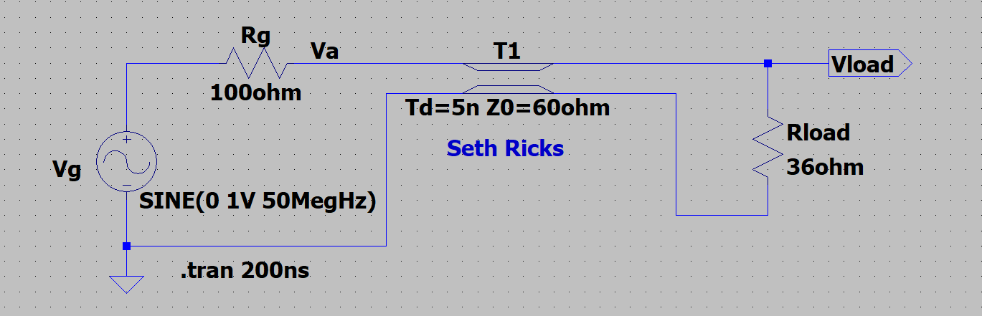

**Figure 4:** Simulation Circuit for a ¼ Wavelength Transmission Line Circuit.

1. After running the simulation, a Plot Pane will open in which you are to select the waveforms **V(va)** and **V(vload)** for display. Also go to **Plot Settings 🡪 Mark Data Points** to see each individual simulated data point.
2. Next zoom in on the plot by going to **Plot Settings 🡪 Manual Limits**, which opens a **Plot Limits** pane in which to adjust the horizontal axis limits to span from 100 ns to 200 ns with a 20 ns tick.
3. Using one of the waveform cursors, determine the peak voltage of both **V(va)** and **V(vload)**. Both the mouse and the left and right arrow keys can be used to move the waveform cursors along a given trace. The cursors move to the next data point with the arrow keys, whereas the mouse provides for cursor location between actual data points.
4. Next drag the cursor pane onto your plot to document your peak values as illustrated in the figure below.
5. In the Plot Settings pull-down menu on the main LTspice toolbar, annotate your plot with your name as follows: **Plot Settings 🡪 Notes & Annotations 🡪 Place Text**.
6. Replace the plot pane in **Figure 5** below with your version. Note: The vertical axis has been altered in the plot shown below, meaning your results should look differently on the vertical axis. (8 points.)

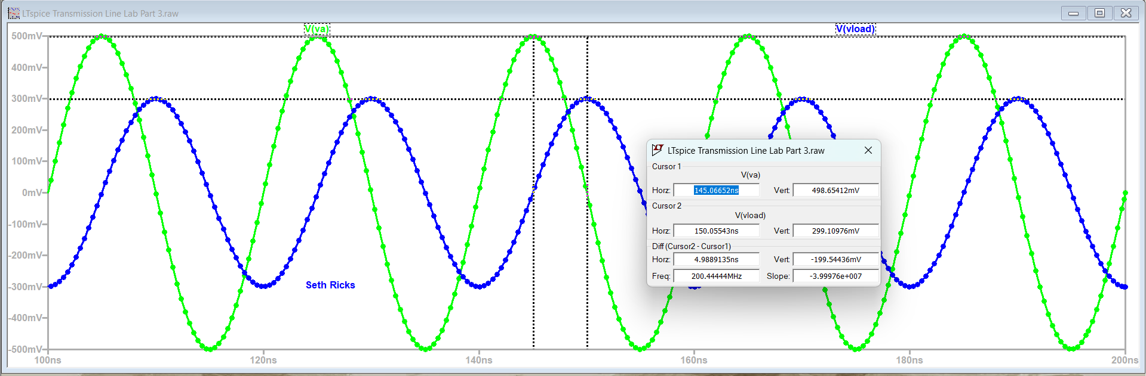

**Figure 5:** Simulated Results for a ¼ Wavelength Lossless Transmission Line Circuit of **Figure 4**.

1. Record your simulated peak values of **V(va)** and **V(vload)** below in **Table 2**, along with a calculated **Pload_av** value. For the circuit of **Figure 4**, since ≠ 0, for , and **V(vload)** is directly available from the simulation, the average power delivered to the load is best calculated as follows:

**Table 2**: LTspice Simulated Values for ¼ Wavelength Circuit of **Figure 4**.

|  |  |  |  |  |
| --- | --- | --- | --- | --- |
| **Length L (m)** | **Td** | **Va_pk** | **Vload_pk** | **Pload_av** |
| λ/4 | 5.00 ns | 498.7 mV | 299.1 mV | 1.24 mW |

**Discussion and Conclusions Questions:** (For the following questions use your own words along with complete sentences. Answer your questions so that readers can understand your response without having to read the question.)

1. Assuming up = (2/3)c, calculate the length of a ½ wavelength transmission line for a sinusoidal frequency of 10 MHz. (2 points.)

λ/2 = 10 m (2 points.)

1. Briefly explain if there are reflections on the ½ wavelength transmission line of the circuit illustrated in **Figure 2**. (1 point.)

There are not any reflections for the circuit in Figure 2. This is because with a lossless line of wavelength nλ/2, Zin= ZL. And since Zg = ZL = 100 ohm in this scenario, the load matches the source. This means no reflections.

1. Explain why using a ¼ wavelength transmission line used as an impedance transformer between a load and source is undesirable for a 100 kHz sinusoidal signal, given . (Hint: Calculate the associated wavelength.) (2 points.)

A transmission line of 500 m would be unrealistic for a regular circuit. It would be cheaper and easier to pursue other methods.

**Transmission Line Lab Grading Rubric:** **This is a CAD lab to be done individually, rather than in teams, although please help each other out if/when opportunities arise, avoiding plagiarism. Submit an electronic version of a lab report to receive credit for doing this lab.** The goal of your **lab report is to provide sufficient documentation so that others could re-create your results.** Therefore, simply add to this document to arrive at your lab report, as all of the explanatory text, procedures and Discussion and Conclusion questions contained in this document are required for a complete lab report. So for your lab report, **add a cover page, your results, along with your answers to the Discussion and Conclusions questions to the existing lab document**. Your answers to the **Discussion and Conclusions** questions are to **be uniquely yours** and not a copy of someone else’s answers to these questions. Your cover page is to include class, lab title, and author. The rubric below does not need to be included in your lab report.

|  |  |
| --- | --- |
| **Lab Report Item** | **Points** |
| Cover Page | 1 |
| **Part 1 - Power Flow on a Transmission Line.**  Pload_av Calculation. (2 points.) | 2 |
| **Part 2 - ½ Wavelength Transmission Line.**  **Figure 2**: (7 points total. 1 point for voltage source with **SINE(0 1 50Meg 0 0 0 0)** configuration statement, 1 point for Rg, 1 point for Rload, 2 points for T1 having correct Td and Zo values, 1 point for **.tran 200ns** statement, 1 point for name included on schematic.)  **Figure 3:** (8 points total. 1 point for **V(va)** trace, 1 point for **V(vload)** trace, 1 point for 100 ns to 200 ns horizontal plot limits, 2 points for cursor pane included, 2 points for correct peak voltage values, 1 point name included on the plot pane.)  **Table 1:** (12 points total. 1 point per entry. -0.25 point per each missing unit.) | 27 |
| **Part 3 – 1/4 Wavelength Transmission Line.**  Z0 Calculation. (2 points.)  **Figure 4**: (7 points total. 1 point for voltage source with **SINE(0 1 50Meg 0 0 0 0)** configuration statement, 1 point for Rg, 1 point for Rload, 2 points for T1 having correct Td and Zo values, 1 point for **.tran 200ns** statement, 1 point for name included on schematic.)  **Figure 5:** (8 points total. 1 point for **V(va)** trace, 1 point for **V(vload)** trace, 1 point for 100 ns to 200 ns horizontal plot limits, 2 points for cursor pane included, 2 points for correct peak voltage values, 1 point name included on the plot pane.)  **Table 2:** (4 points total. 1 point per entry. -0.25 point per each missing unit.) | 21 |
| Discussion and Conclusions | 5 |
| Grammar and Professionalism | 4 |
|  |  |
| **Total** | 60 |

Please give feedback on errors you find in this document.